WATER STRUCTURE THOUGHTS- RJD and PSHS

RJD: This is the point about water I keep meaning to make. Structured water the molecules take on a crystal lattice formation which is an expression of the icosahedron energy field it resides in. This energy field holds all knowledge and transports information and explains the structure of the earth's energy grid which is also expressing the same thing. Could be wrong. Intuition and all.

Ps Hs, [18-01-2025 18:38]
YES!

Ps Hs, [18-01-2025 18:39]
When unstructured, water takes that shape naturally when freezing. Thus, When structured water dips below 0, it never freezes, because it is already in a crystal lattice formation

Ps Hs, [18-01-2025 18:39]
Thus, the reasoning behind the pyramid water experiment

Ps Hs, [18-01-2025 18:40]
And this energy field, this mode of transport, when in longitudinal movement, through time, it has this shape -
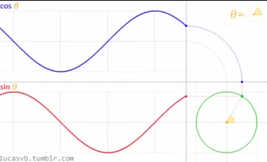
Ps Hs, [18-01-2025 18:40]
The Crystal is a Trap to Express the Wave

Ps Hs, [18-01-2025 18:41]
Ahh it makes me so excited where our knowledge is going.

RJD: And DNA is an antenna.

Pshs: RJD, [18-01-2025 18:41]
And DNA is an antenna.

Ps Hs, [18-01-2025 18:42]
https://www.researchgate.net/publication/382458403_Double_helical_plasmonic_antennas
Biomimicry

RJD: And cells communicate via EMF/light which is our aura.

